Phase-1

2. Demonstrate Connection, Statement, and Result Set in JDBC.

package jdbcdemo;

import java.sql.Connection;

import java.sql.DriverManager;

import java.sql.ResultSet;

import java.sql.SQLException;

import java.sql.Statement;

public class Demo1 {

public static void main(String[] agrs) throws ClassNotFoundException,SQLException {

String dbUrl = "jdbc:mysql://localhost:3306/animated_movies";//Connection String

String username = "root";

String password = "root";

String query = "select * from movies;";

Class.forName("com.mysql.cj.jdbc.Driver");

Connection con = DriverManager.getConnection(dbUrl,username,password);//Connecting to DB

Statement stmt = con.createStatement();

ResultSet rs = stmt.executeQuery(query);//Save the result after executing the query

while (rs.next()) {

System.out.print("Title: " + rs.getString ("title") +"\t");

System.out.print("Genre: " + rs.getString ("genre") +"\t");

System.out.print("Director: " + rs.getString ("director") +"\t");

System.out.println("Release Yea: " + rs.getString ("release_yea"));

}

}

}

Output:

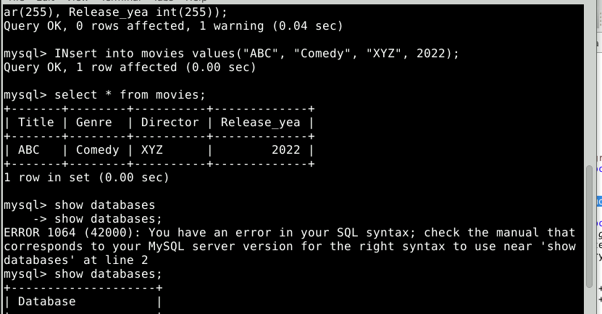

4. Demonstrate how to create, select, and drop a database in JDBC.

package jdbcdemo;

import java.sql.SQLException;

import java.sql.Connection;

import java.sql.DriverManager;

import java.sql.Statement;

public class demo3 {

public static void main (String[] args) throws ClassNotFoundException,SQLException {

String dbUrl = "jdbc:mysql://localhost:3306";

String username = "root";

String password = "root";

String query = "Create Database action_movies;";

Connection con = null;

try {

Class.forName("com.mysql.cj.jdbc.Driver");

con = DriverManager.getConnection(dbUrl, username, password);

Statement stmt = con.createStatement();

stmt.execute(query);

}

catch (Exception e) {

System.out.println(e.getMessage());

}

finally {

con.close();

}

}

}

OUTPUT :

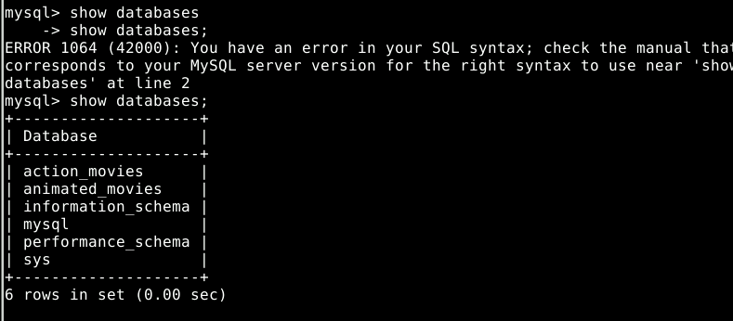

3.Demonstrate stored procedures and exception handling in JDBC.

Package jdbcdemo;

import java.sql.Connection;

import java.sql.DriverManager;

import java.sql.ResultSet;

import java.sql.SQLException;

import java.sql.Statement;

public class DEMO2 {

public static void main(String[] agrs) throws ClassNotFoundException,SQLException {

String dbUrl = "jdbc:mysql://localhost:3306/animated_movies";//Connection String

String username = "root";

String password = "root";

String query = "Call SelectAllMovies();";

Connection con = null;

try {

Class.forName("com.mysql.cj.jdbc.Driver");

con = DriverManager.getConnection(dbUrl,username,password);//Connecting to DB

Statement stmt = con.createStatement();

ResultSet rs = stmt.executeQuery(query);//Save the result after executing the query

while (rs.next()) {

System.out.print("Title: " + rs.getString ("title") +"\t");

System.out.print("Genre: " + rs.getString ("genre") +"\t");

// System.out.print("Director: " + rs.getString ("director") +"\t");

System.out.println("Release Yea: " + rs.getString ("release_yea"));

}

}

catch (Exception e) {

System.out.println(e.getMessage());

}

finally {

con.close();

}

}

5. Demonstrate database record handling using JDBC

package jdbcdemo;

import java.sql.Statement;

import java.sql.Connection;

import java.sql.DriverManager;

public class demo6 {

public static void main(String[] args) {

String dbUrl = "jdbc:mysql://localhost:3306/animated_movies";//Connection String

String username = "root";

String password = "root";

String query = "INSERT INTO movies VALUE(\"Finding Nemo\", \"Comedy-Drama\", \"Andrew Stanton\", 2003);";

Connection con = null;

try {

Class.forName("com.mysql.cj.jdbc.Driver");

con = DriverManager.getConnection(dbUrl, username, password);

Statement stmt = con.createStatement();

stmt.execute(query);

}

catch (Exception e) {

e.printStackTrace();

}

}

}

ii) package jdbcdemo;

import java.sql.Connection;

import java.sql.DriverManager;

import java.sql.Statement;

public class demo7 {

public static void main(String[] args) {

String dbUrl = "jdbc:mysql://localhost:3306/animated_movies";//Connection String

String username = "root";

String password = "root";

String query = "UPDATE movies SET Genre = 'Comdey Drama' where title = 'Finding Nemo';";

Connection con = null;

try {

Class.forName("com.mysql.cj.jdbc.Driver");

con = DriverManager.getConnection(dbUrl, username, password);

Statement stmt = con.createStatement();

stmt.execute(query);

}

catch (Exception e) {

e.printStackTrace();

}

}

}

package jdbcdemo;

import java.sql.Connection;

import java.sql.DriverManager;

import java.sql.Statement;

public class demo8 {

public static void main(String[] args) {

String dbUrl = "jdbc:mysql://localhost:3306/animated_movies";//Connection String

String username = "root";

String password = "root";

String query = "DELETE from movies where title = 'Finding Nemo';";

Connection con = null;

try {

Class.forName("com.mysql.cj.jdbc.Driver");

con = DriverManager.getConnection(dbUrl, username, password);

Statement stmt = con.createStatement();

stmt.execute(query);

}

catch (Exception e) {

e.printStackTrace();

}

}

}

Output:

